**NM Team ID:** NM2023TMID06438

**Project Name:** How to add Google Analytics to the Website

**Leader Name:** Jeyasurya. P

**NM ID:** 051CC2357F8F820B6BE4B8BC660FB7E7

**Group Members Name:**

1. Rajkumar K
2. Sivasakthivel T
3. Samynathan V
4. Introduction

Overview:

How to add Google Analytics to a Website.

Purpose:

To collect the data of visitors and viewership of the website and to measure the traffic of the site to improve the site.

1. Result:

A new stream is created for the Website in the google analytics to collect the data to measure the traffic of the site.

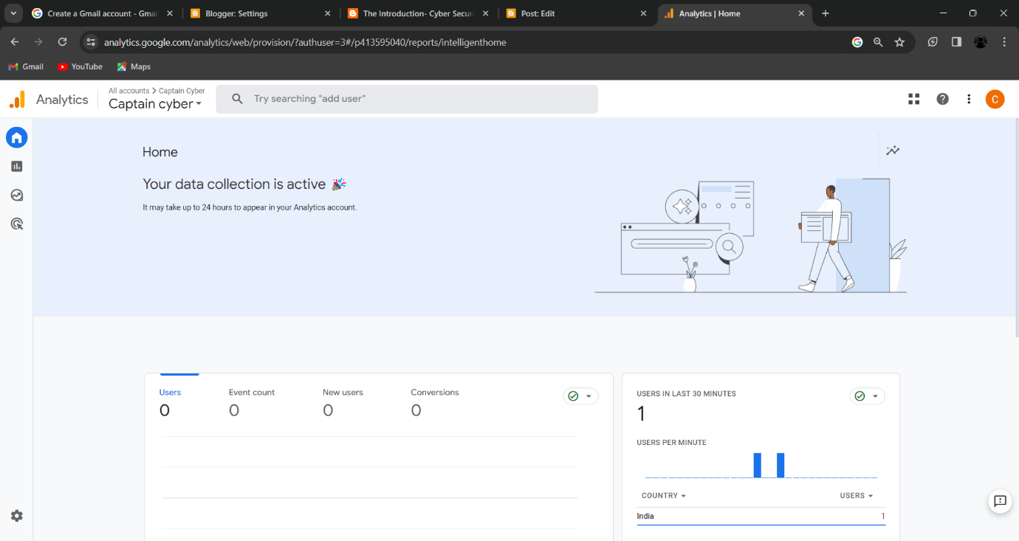

1. Advantages & Disadvantages:

Advantages:

The google analytics measures the traffic of the site and gives a detailed information about the reach of the site.

Helps to improve the aesthetics of the website by revising the traffic.

Disadvantages:

Some websites may require paid subscription to avail the Google Analytics service in the platform.

1. Applications:

The Google Analytics can be added to any website by which we can get the details about the visitors, their country and pages they visited. By using these data, we can focus on the topics that has many visitors then the other topics which will eventually improve the site traffic.

1. Conclusion:

The Project of adding Google Analytics was really helpful to improve the website standards. During the process we have learned to create a new website, the use and working of google Analytics.